**Offline Checkout – Standalone**

**Background:**

We recently discovered that the offline checkout interface in the browser client has some incompatibilities with the way we have Chrome set up at KCLS, and those cause issues with offline usage/data loss. That Chrome setup is necessary for Office 365 to work smoothly on shared stations, so we are unable to resolve the issues with browser based offline checkouts.

It was then decided that it would be useful to have a standalone windows app that can be used for offline checkout. In addition to fixing the data loss issues, it should also be simpler for staff to bring up and access.

Although it does attempt to mimic the existing offline checkout interface somewhat, it also adds some new features such as storing info when the patron doesn’t have their card number, etc. The procedure to process the offline data is also different, will go into more detail below.

**App Intro:**

The “Offline Checkout – Standalone” app will be distributed via the software center for optional instllation (mandatory on branch PCs?). Once installed, there will be a desktop and start menu icon for starting the app. Once started, staff will see this interface:

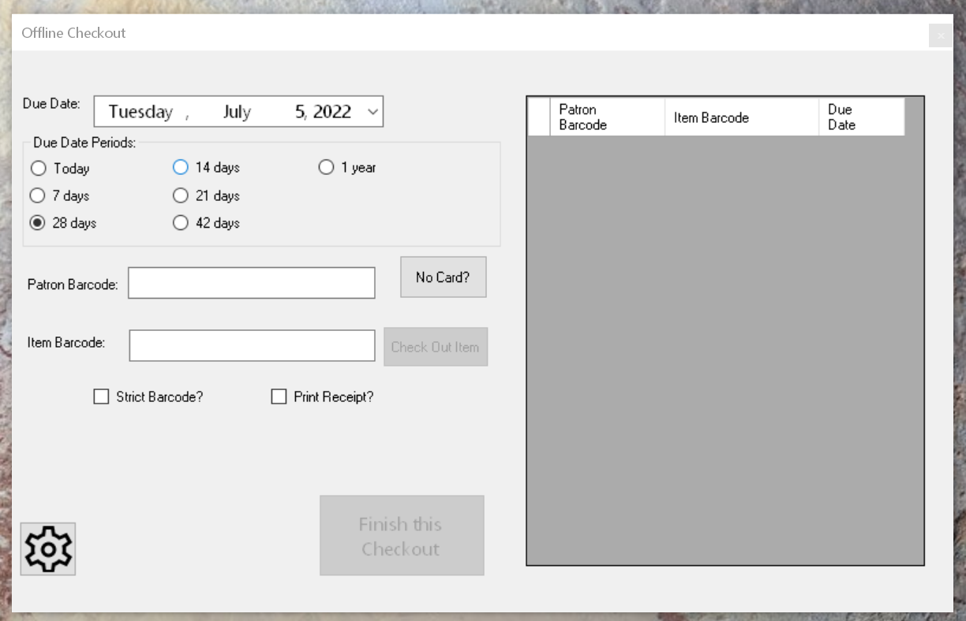

**Basic Usage:**



1. Enter Patron barcode if known. If not known, press the “No Card?” button. Pressing the “No Card?” button brings up the following popup to allow staff to enter in patron details. 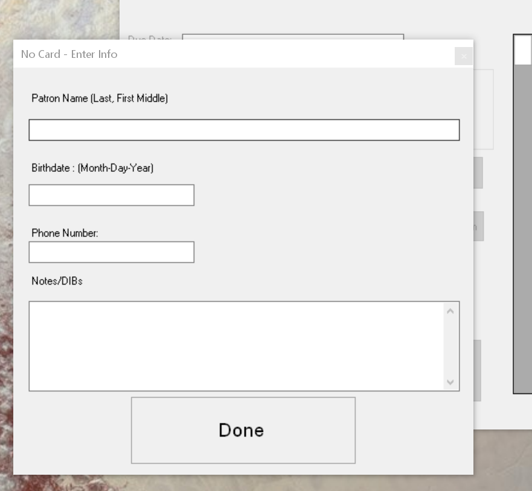
2. Choose due dates, from either the date entry calendar field, or using the preset period buttons.
3. Scan/enter in item barcodes
4. Press “Finish this Checkout”. This saves the checkout data immediately to a file on the staff desktop.

**Advanced Usage/Setup notes**

As staff use the app for offline checkout, it creates simple text files on the windows desktop, called “OFFLINE_2022-06-07.txt” (for example) and if there are “No Card?” patrons, it also creates a file called “OFFLINE_NO_CARD_2022-06-07.txt”.

1. **Standard offline transactions (with card)**

The first standard offline file is designed to be imported into Evergreen once the branch is back online for Evergreen to upload and process the file. Note that this is a bit different workflow than exists if done in the browser client’s offline – the transactions aren’t available for processing immediately, they have to be imported first. To import them, simply go to the browser “Offline Circulation” option once online and you will see the “Import Transactions” button.

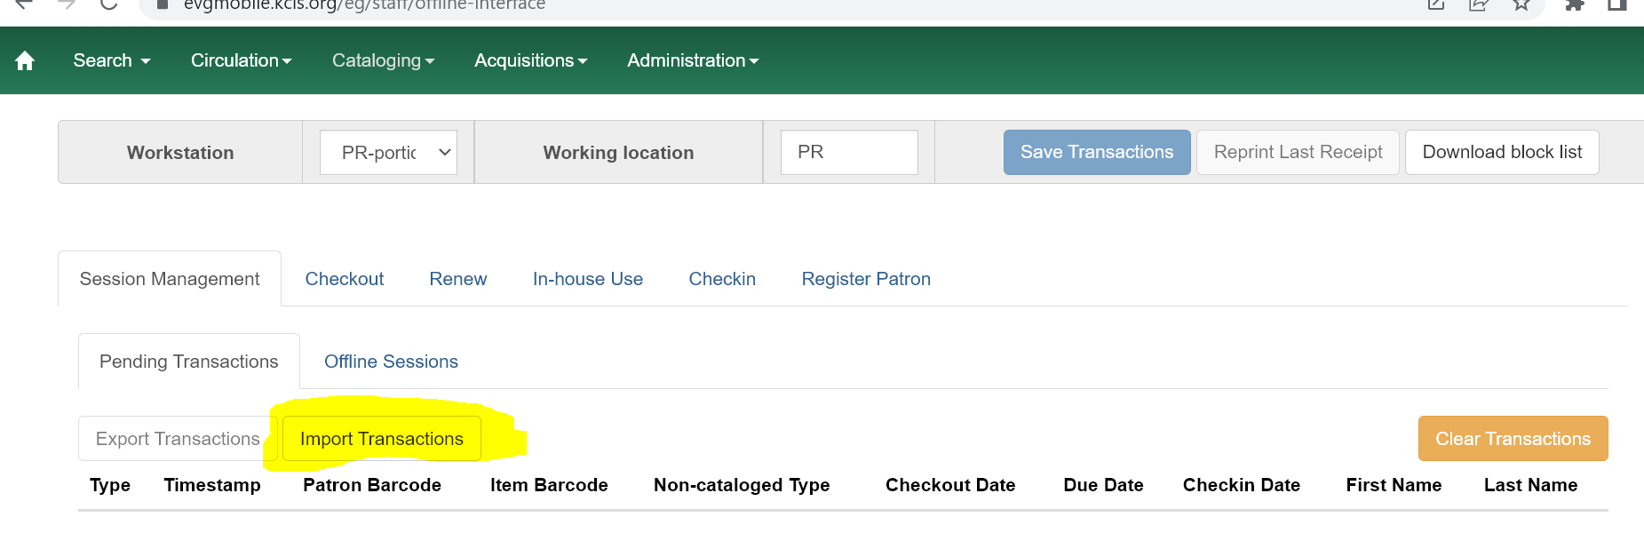

Pressing that button will open a windows file dialog where staff can choose the offline file created on the desktop. Once imported, the offline upload/processing steps are the same as before.

1. **Transaction with No Card**

These transactions are stored in a separate text file on the desktop. Opening that file will show a human readable file showing the patron info, notes, and items/due dates for staff manual entry. (This is intended to replace the existing word templates)

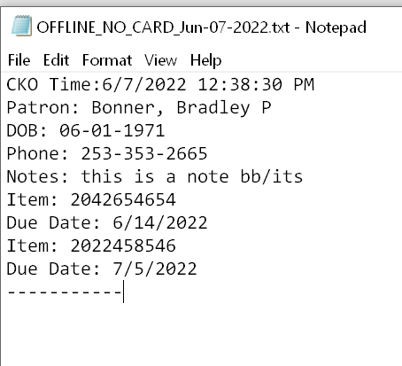

Also, if staff have an Epson receipt printer set up, it will also print out a staff receipt after every transaction that contains this info, but also has scannable barcodes to help assist with manual data entry.

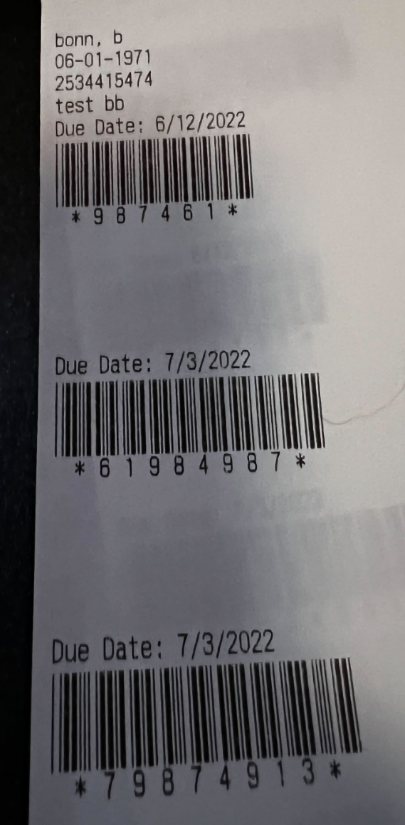

**Setup Options**

Pressing the “Gear” button will bring up a spot to choose which printer to use, if they have one attached.

**Strict Barcode :** If enabled, this will pop up a warning if an entered patron or item barcode do not conform to the standard codabar format checks.

**Print Receipt? :**  If a printer is set up, it will print a basic checkout receipt. 